CSA0603 DESIGN AND ANALYSIS OF ALGORITHM
Introduction
Matrix Chain Multiplication is a Dynamic Programming problem used to find the most efficient way to multiply a sequence of matrices. Matrix multiplication is associative, so the order of multiplication can be changed without changing the final result. However, different orders require different numbers of scalar multiplications.
Problem Statement
Given a sequence of matrices, determine the optimal parenthesization that minimizes the total number of scalar multiplications.
For example:
A1 × A2 × A3
can be multiplied as:
- (A1 × A2) × A3
- A1 × (A2 × A3)
Both produce the same result, but their costs are different.
CORRECT CODE:
#include <stdio.h>
#include <limits.h>
int main() {
int n = 4;
int arr[] = {10, 20, 30, 40};
int dp[10][10];
int i, j, k, len, cost;
for (i = 1; i < n; i++)
dp[i][i] = 0;
for (len = 2; len < n; len++) {
for (i = 1; i <= n - len; i++) {
j = i + len - 1;
dp[i][j] = INT_MAX;

for (k = i; k < j; k++) {
cost = dp[i][k] + dp[k + 1][j]
+ arr[i - 1] * arr[k] * arr[j];
if (cost < dp[i][j])
dp[i][j] = cost;
}
}
}
printf("Minimum Cost = %d\n", dp[1][n - 1]);
return 0;
}
OUTCOME:
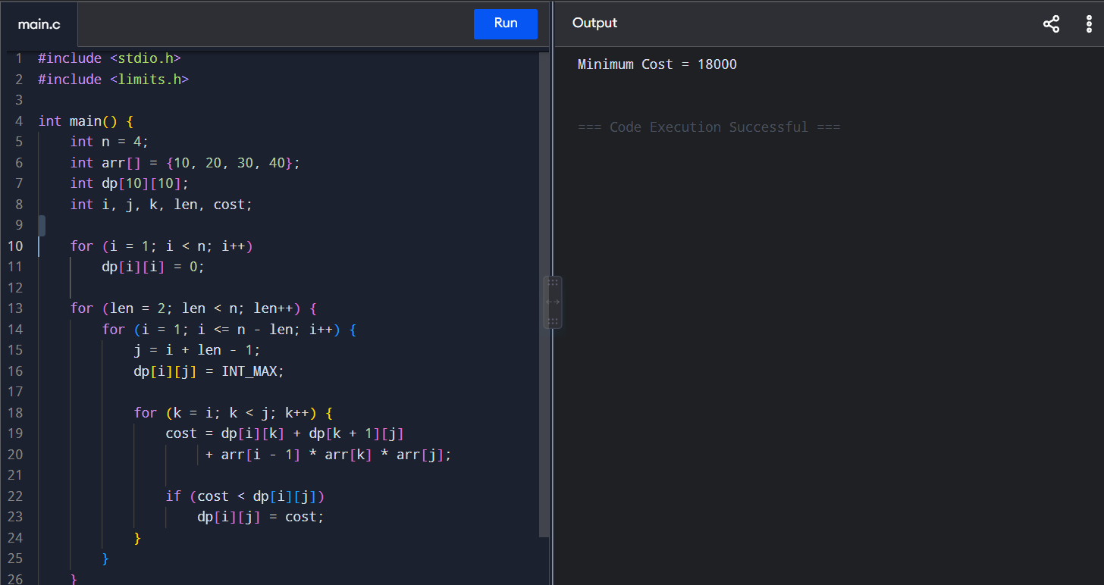
Advantages
- Reduces unnecessary calculations.
- Finds the optimal multiplication order.
- Uses previously calculated subproblems.
- Suitable for a large number of matrices.
Complexity
- Time Complexity: O(n³)
- Space Complexity: O(n²)
Conclusion
Matrix Chain Multiplication uses Dynamic Programming to find the minimum number of scalar multiplications required. For the given input, the minimum cost is 18000.

